SendMail application

# Create an App registration

An application must be registered in Azure Active Directory prior to running the script.

1. Open the Azure AD [portal](https://aad.portal.azure.com/#blade/Microsoft_AAD_IAM/ActiveDirectoryMenuBlade/Overview) and go to *App registrations*
2. Select *New registration*
3. Provide a name for your application and select Register

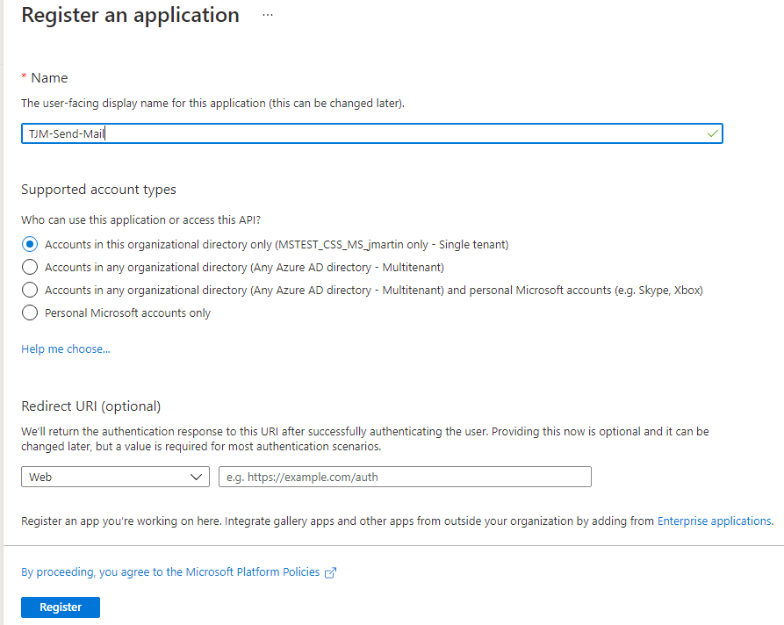

1. Copy the Application (client) ID and the Directory (tenant) ID for later use

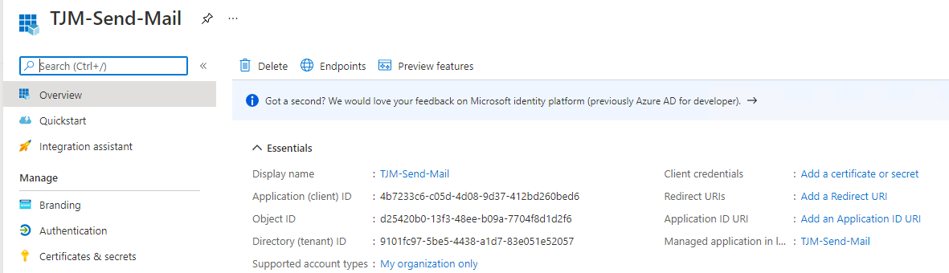

1. Select *Add a certificate or secret*
2. Select *New client secret* under the *Client secrets* section
3. Enter a *Description* and select a duration under the *Expires* drop-down menu

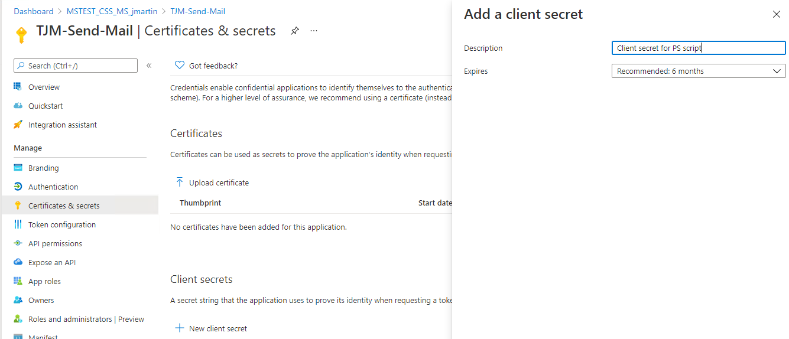

1. Copy the Value for your new client secret

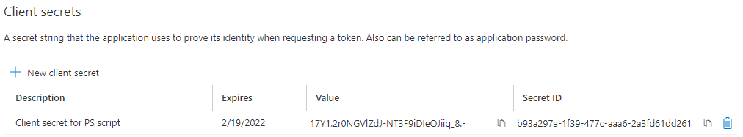

1. Select *API* *permissions* under the *Manage* options
2. Select *Add a permission* under the *Configured permissions* section
3. Select *Microsoft Graph* under the *Microsoft APIs*
4. Enable the Mail.Send permission for Application permissions and select Add permission

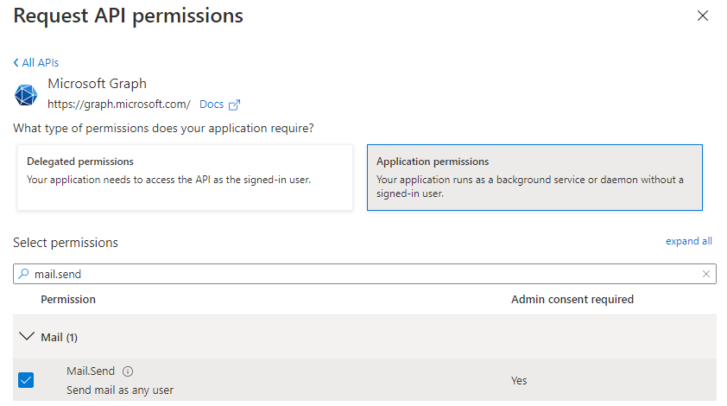

1. You may need to select Grant admin consent for <Tenant name> depending on your settings

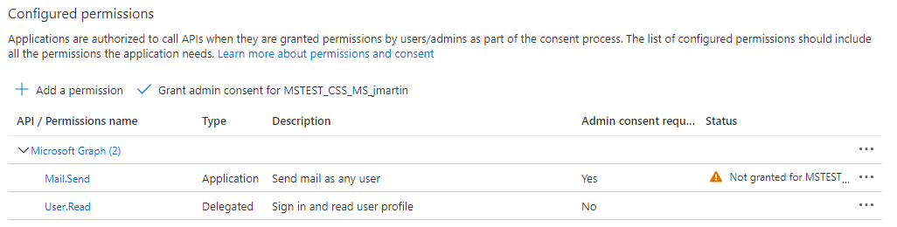

1. Select *Yes* to the Grant admin consent confirmation window